Q1: Write a program to simulate the working of stack using an array with the following:
a) Push
b) Pop
c) Display
The program should print appropriate messages for stack overflow, stack underflow

#include <stdio.h>
#include <stdlib.h>
#define MAX 5

int stack[MAX];
int top = -1;

void push() {
int value;
if (top == MAX - 1) {
printf("\nStack Overflow! Cannot push element.\n");
} else {
printf("Enter value to push: ");
scanf("%d", &value);
top++;
stack[top] = value;
printf("Pushed %d onto the stack.\n", value);
}
}

void pop() {
if (top == -1) {
printf("\nStack Underflow! Cannot pop element.\n");
} else {
printf("Popped element: %d\n", stack[top]);
top--;
}
}

void display() {
if (top == -1) {
printf("\nStack is empty.\n");
} else {
printf("\nStack elements are:\n");
for (int i = top; i >= 0; i--) {
printf("%d\n", stack[i]);
}
}
}

int main() {
int choice;
while (1) {
printf("\n--- Stack Operations ---\n");
printf("1. Push\n");
printf("2. Pop\n");
printf("3. Display\n");
printf("4. Exit\n");
printf("Enter your choice: ");
scanf("%d", &choice);

switch (choice) {
case 1:
push();
break;
case 2:
pop();
break;
case 3:
display();
break;
case 4:
printf("Exiting program...\n");
exit(0);
default:
printf("Invalid choice! Please try again.\n");
}
}
return 0;
}

OUTPUT:
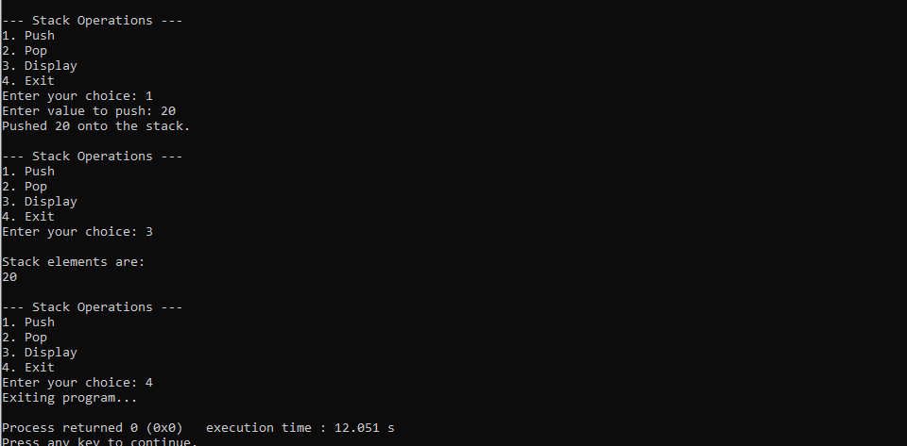

Q2: WAP to convert a given valid parenthesized infix arithmetic expression to postfix expression. The expression consists of single character operands and the binary operators + (plus), - (minus), * (multiply) and / (divide)

#include <stdio.h>
#include <ctype.h>
#include <stdlib.h>

#define MAX 100

char stack[MAX];
int top = -1;

void push(char c) {
if (top == MAX - 1)
printf("Stack Overflow\n");
else
stack[++top] = c;
}

char pop() {
if (top == -1) {
printf("Stack Underflow\n");
return -1;
} else {
return stack[top--];
}
}

int precedence(char op) {
switch (op) {
case '+':
case '-': return 1;
case '*':
case '/': return 2;
default: return 0;
}
}

int isOperator(char c) {
return (c == '+' || c == '-' || c == '*' || c == '/');
}

void infixToPostfix(char infix[]) {
char postfix[MAX];
int i = 0, j = 0;
char symbol, temp;

printf("\nPostfix Expression: ");

while ((symbol = infix[i++]) != '\0') {
if (isalnum(symbol)) {

postfix[j++] = symbol;
} else if (symbol == '(') {
push(symbol);
} else if (symbol == ')') {

while ((temp = pop()) != '(') {
postfix[j++] = temp;
}
} else if (isOperator(symbol)) {

while (top != -1 && precedence(stack[top]) >= precedence(symbol)) {
postfix[j++] = pop();
}
push(symbol);
} else {
printf("\nInvalid character encountered: %c\n", symbol);
return;
}
}

while (top != -1) {
postfix[j++] = pop();
}

postfix[j] = '\0';
printf("%s\n", postfix);
}

int main() {
char infix[MAX];

printf("Enter a valid infix expression: ");
scanf("%s", infix);

infixToPostfix(infix);

return 0;
}

OUTPUT:
